

,

**Previos Speaker**

***September 10, 2013***

**Scott Westerman***e*

*Head of the MSU Alumni Association*

Scott covered many tangible steps to better yourself in school and is a person in general through several steps he offered. Through life lessons, Scott really had students thinking about exactly what they want to do when they graduate college early on!

**UCA Opportunities**

* Networking
* Portfolio Building
* Workshops
* Executive Board Openings

**Become a paid member!  
Dues: *$25***Free UCA shirt and reduced event prices for paid members. Members who’ve paid dues get first consideration for Executive Board.

A pre-professional organization for undergraduates in the field of communication at MSU.

Our goal is to provide education, leadership, assistance and unique opportunities to students as they prepare for careers within the communication fields.

# LETTER FROM THE PRESIDENT

UCA News

Undergraduate Communication Association

Volume 5, Issue 2

October 2013

MICHIGAN STATE UNIVERSITY

Welcome to our second meeting of the academic year. We are excited to have you joining us tonight. I hope your classes are off to a great start. Can you believe we have already tackled a month?

Scott Westerman, our first meeting’s speaker, shared some fantastic advice. He told us he is more than happy to sit and talk personally with anyone who would like to meet with him. Please don’t hesitate to reach out to him.

As always, feel free to chat with me, or anyone on the Executive Board, after the meeting.

Go Green!

Jordan

**2013-2014 Executive Board Contact Information**

**Jordan Wray**  
President  
Email: wrayjor1@msu.edu  
Twitter: @Jwrayyy

**Julia Garvey**  
Vice President of Public Relations  
Email: garveyju@msu.edu

**Lexie Fiema**  
Vice President of Member Relations Communiciation  
Email: fieemaale@msu.edu

**Matt Markachev**  
Vice President of Internal Communication  
Email: [markach1@msu.edu](mailto:markach1@msu.edu)  
Twitter: @mattmarkachev

**Lauren Kimbrue**

Vice President of Programming

Email:kimbruel@msu.edu

Twitter: @kimbruel

**Kara Miencier**

Vice President of Alumni Relations

Email: [miencie1@msu.edu](mailto:jordanwray12@gmail.com)

**Hiba Naseem**

Vice President of Finance/Fundraising

Email: [naseemhi@msu.edu](mailto:naseemhi@msu.edu)

Twitter: (Twitterless)

**Bruce Tus**

Co-chair of Finance

Email: tusbruce@msu.edu

A lot of students believe that the idea of college is to get an education, and somehow that will translate to them getting a job out of college. Well in today's world, that's not necessarily true.

In today's world, there are way too many students just graduating with a degree that it almost makes it impossible to stand out from

others with just an education.

That's why college is not just for the education, it's for the **experience** you get from it. In today's world, employers are looking for students who already have experience in the line of work they are looking for, and the easiest way to get that experience is just to get involved! Whether it is getting involved with a club on campus, a job, or an internship, employers see it as an initiative to get to know the workplace.

This is why internships are so great, they give you a chance to job shadow other employees and get experience, even if you are interested in that field of work!

It is important to know, however, to start early, preferably freshman year, as many students start late and feel overstressed come senior year!

# Finding an Internship: Why It's Important

**Social Media**Facebook: MSU Undergraduate Communication Association  
Twitter: @MSU_UCA  
LinkedIn: MSU's Undergraduate Communication Association

**UCA Contact Information**Email: [msu.uca@gmail.com](mailto:msu.uca@gmail.com)

Office: Room 452 College of Communication Arts and Sciences

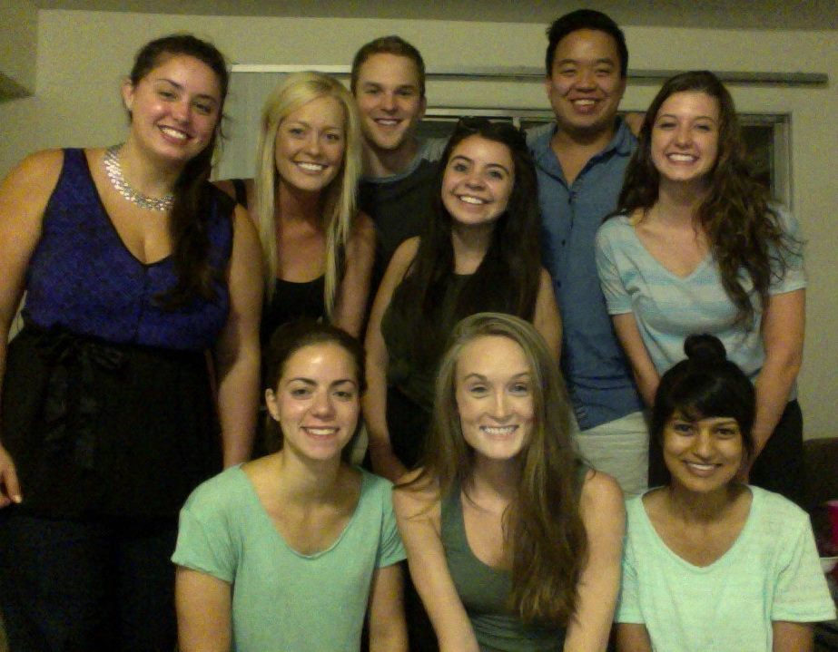

**Matt Markachev**  
*VP of Internal Communications*