

,

**Speaker**

***September 10, 2013***

**Scott Westerman***e*

*Head of the MSU Alumni Association*

Being an MSU Alumni, Scott is filled with a wealth of experience, including all the ups and downs involved with the transition from college to the professional world and figuring out what your true passion is. Make sure to give him a warm welcome and absorb his wisdom!

**UCA Opportunities**

* Networking
* Portfolio Building
* Workshops
* Executive Board Openings

**Become a paid member!  
Lowered Dues: *$25***Free UCA shirt and reduced event prices for paid members. Members who’ve paid dues get first consideration for Executive Board.

A pre-professional organization for undergraduates in the field of communication at MSU.

Our goal is to provide education, leadership, assistance and unique opportunities to students as they prepare for careers within the communication fields.

# LETTER FROM THE PRESIDENT

UCA News

Undergraduate Communication Association

Volume 4, Issue 4

January 2013

MICHIGAN STATE UNIVERSITY

Welcome to the Undergraduate Communication Association’s first meeting of the 2013-2014 academic year. We are so happy to have you joining us.

Our goal as the UCA is to provide education, leadership, assistance and unique opportunities to students as they prepare for careers within the Communication fields. The UCA does this by providing resources, seminars and advice on issues such as graduate school, career preparation, job searches, internships and organizes opportunities for communication students to get to know the faculty and their peers to further students crucial networking skills.

I have great expectations for this year. With so many successful alumni working in the industry, we have great leaders who can teach us many things.

Please enjoy our brilliant speaker, and we look forward to seeing you at our next meeting.

Go Green!

Jordan

**2013 Executive Board Contact Information**

**Jordan Wray**  
President  
Email: wrayjor1@msu.edu  
Twitter: @Jwrayyy

**Julia Garvey**  
Vice President of Public Relations  
Email: garveyju@msu.edu

**Lexie Fiema**  
Vice President of Member Relations Communiciation  
Email: fieemaale@msu.edu

**Matt Markachev**  
Vice President of Internal Communication  
Email: [markach1@msu.edu](mailto:markach1@msu.edu)  
Twitter: @mattmarkachev

**Lauren Kimbrue**

Vice President of Programming

Email:kimbruel@msu.edu

Twitter: @kimbruel

**Kara Miencier**

Vice President of Alumni Relations

Email: [miencie1@msu.edu](mailto:jordanwray12@gmail.com)

**Hiba Naseem**

Vice President of Finance/Fundraising

Email: [naseemhi@msu.edu](mailto:naseemhi@msu.edu)

Twitter: (Twitterless)

*and last but not least...*

**Bruce Tus**

Co-chair of Finance

Email: tusbruce@msu.edu

When I first got into MSU my freshman year, I was completely overwhelmed with what I needed to do with my major. The main issue to put it simply was I just didn’t know where to start.

Joining UCA has changed this for me. Not only have I learned what employers’ look for on resumes through workshops, I’ve also learned everything I need to know about Graduate School, as well as the ins and outs of various businesses and much more from our guest speakers.

After learning so much from UCA, I decided to apply for the executive board position. Not only has this helped me jump into a leadership role, it has also allowed me to vastly widen my network. It has given me a chance to get involved and get to know the Faculty here in the College of Communication Arts and Sciences, which as an undergraduate is a valuable resource.

Overall, UCA has made my experience much more enjoyable and less stressful as it allowed to get focused on what I really wanted to get out of college.

# How UCA Has Helped Me

**Social Media**Facebook: MSU Undergraduate Communication Association  
Twitter: @MSU_UCA  
LinkedIn: MSU's Undergraduate Communication Association

**UCA Contact Information**Email: [msu.uca@gmail.com](mailto:msu.uca@gmail.com)

Office: Room 452 College of Communication Arts and Sciences

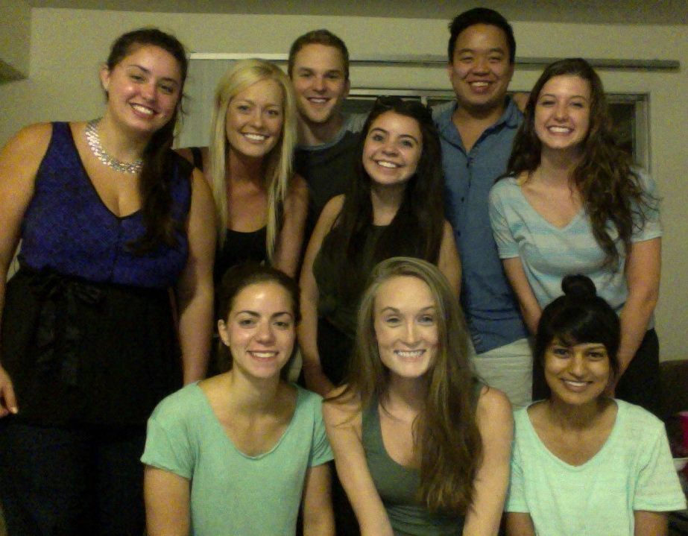

**Matt Markachev**  
*VP of Internal Communications*